**Competitor: Visit Qatar -** [**https://visitqatar.com**](https://visitqatar.com/)

Type: Direct

Activities planning:

* How to get there? (9 out of 10)

Visit Qatar offers the possibility to explore Qatar from a distance before reaching this destination physically. The “practical info” menu drives through everything you need to know about how to arrive in Qatar, how to get a visa, tips for travel, what to do or what to visit.

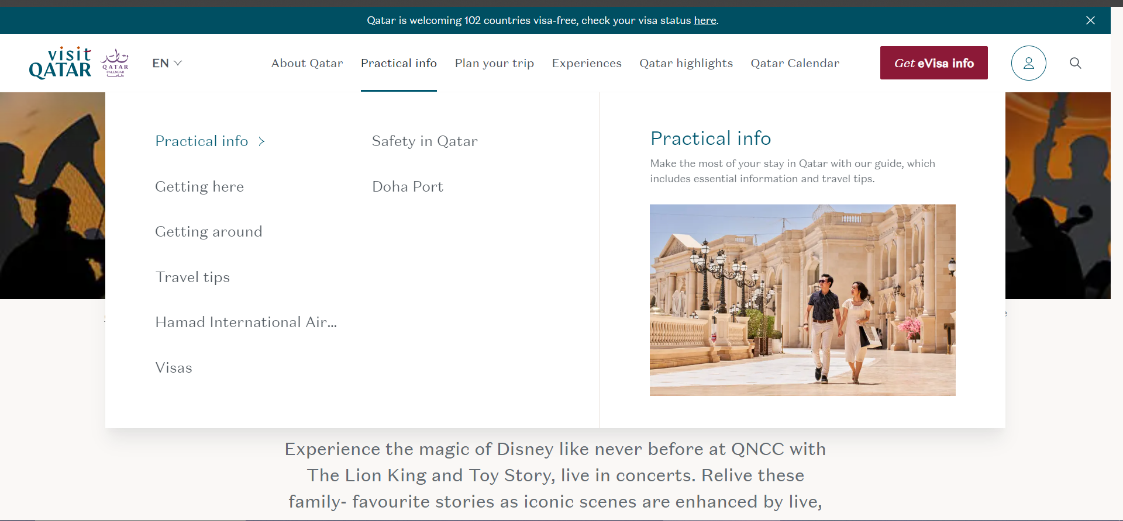

* What to do there (9 out of 10)

The entire site is based on showing as many variants to spend your time as possible. All organized in sections with various tourist spots or offerts. The website offers a large game of ideas for any kind of group of tourists.

<https://visitqatar.com/intl-en/plan-your-trip/itineraries-and-tours>

<https://visitqatar.com/intl-en/experiences/art-and-culture>

<https://visitqatar.com/intl-en/highlights>

* New feature (7 out of 10)

The calendar menu shows details for the main events from the entire year and offers the possibility to buy tickets.

<https://visitqatar.com/intl-en/events-calendar/disney-concerts>

Public/Friends Sharing (7 out of ten): You can find them on facebook, instagram, X, youtube and tiktok.

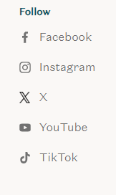

Recommended Destination (only Qatar - 5 out of 10): Visit Qatar is dealing with promoting Qatar and all tourist spots inside the country. Depending on your scope you can choose from a specific category of destination in the “plan your trip menu”.

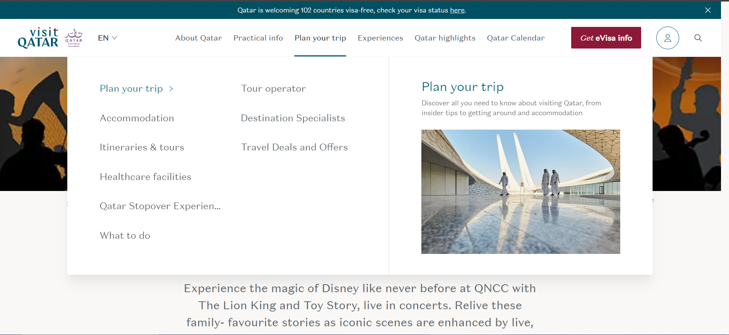

Experience rating (5 out of 10): Visit Qatar uses the rating for TripAdvisor for the majority of their tourist spots.

**Competitor: TripAdvisor**

Trip Advisoris an American travel search engine that provides one-on-one travel and restaurant advice featuring hotel reviews, restaurant reviews, accommodation bookings and other travel-related material. [**https://www.tripadvisor.com/**](https://www.tripadvisor.com/)  
Type: Indirect

Activities planning:

* How to get there? (7 out of 10)

Tripadvisor offers information about flights, restaurants, hotels, cruises and rental cars but not about how to get a visa or what you will need for a specific trip.



* What to do there? (8 out of 10)

On the site you can find specific sections for all the things you can do or visit at your destination.

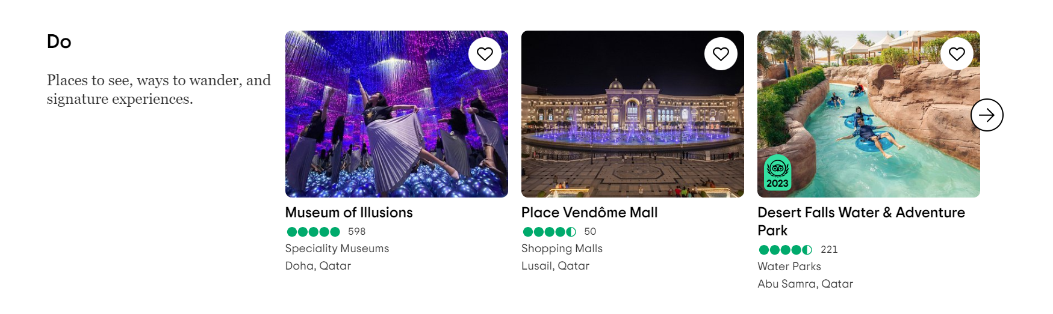

* New feature (10 out of 10): TripAdvisor offers a new perspective for creating trips where you can be helped by AI, but also they let you create your trips on your own.   
  <https://www.tripadvisor.com/Trips>

Public/Friends Sharing (8 out of 10): TripAdvisor can be found on facebook, instagram, X and pinterest, also other applications are using tripadvisor for their ratings.  


Recommended Destination (8 out of 10): TripAdvisor recommends trips all over the world. All you have to do is to introduce your city or country and TripAdvisor will recommend few of the most known places to visit or few of the most popular activities to do.  
<https://www.tripadvisor.com/>

Experience rainting (8 out of 10): TripAdvisor allows users to give feedback for all the destinations and tourist spots.

**Competitor: Google Maps -** [**https://www.google.com/maps/**](https://www.google.com/maps/)

Type: Indirect

Activities planning: -

Public/Friends Sharing (10 out of 10): Google Maps is a specific google application that offers road indication for almost any destination. It is sponsored and recommended by google.

Recommend Destination: -

Experience rating (8 out of 10): 4.3 out of 5 stars on google play, downloaded by over 10 billions people and used at global level

**Competitor: Visit a City -** [**https://www.visitacity.com/**](https://www.visitacity.com/)

Type: Direct

Activities planning:

* How to get there? (4 out of 10)  
  Visit a City does not give information about the road or a visa to get in a specific City, you only can get some tips about their currency, driving, travel with kids, etc

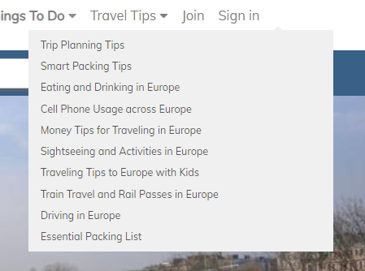

* What to do there? (7 out of 10)

Visit a City offers a big variety of suggested activities about what you can do in a city, also presenting tourists sports, hotels and attractions but the recommendations are taken from TripAdvisor.

<https://www.visitacity.com/en/paris>

* New feature:

Visit a city gives you the chance to take a look at the weather from inside the website. Also they have few template vacations from which you can choose and modify for a specific number of days only for the cities in their list.

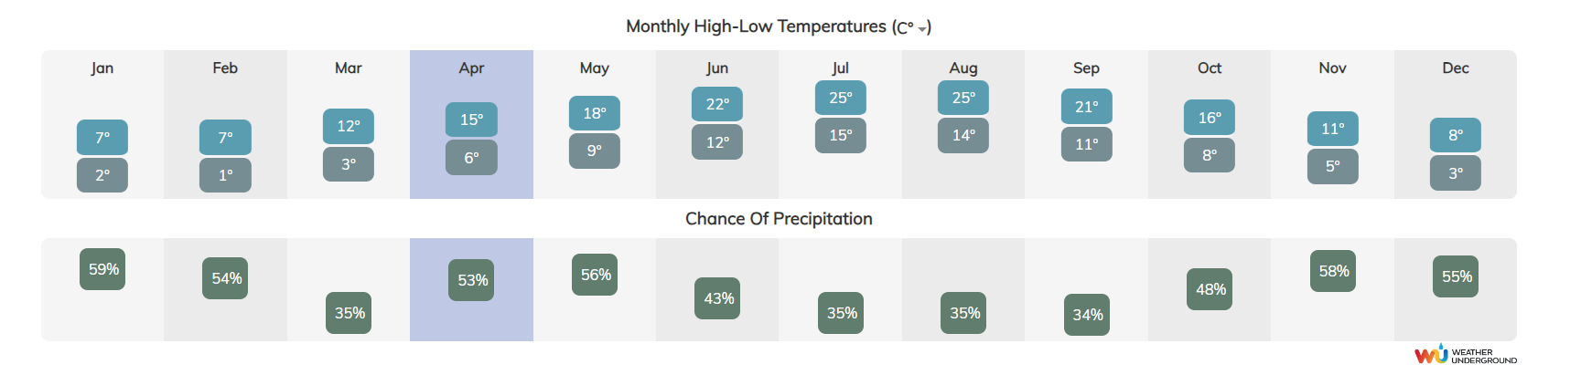

<https://www.visitacity.com/en/paris/itinerary-by-day/3>

Public/Friends Sharing (6 out of 10): You can find Visit a City on facebook, linkedin, pinterest and X.  


Recommend Destination (5 out of 10): Visit a city recommended only cities, you can not search about a specific location or a specific touristic place.